Code Libraries
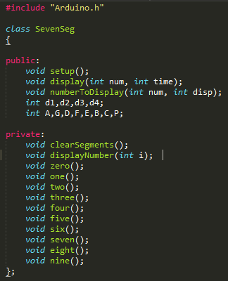
A library is a file containing some related set of functions that we might want to import into projects to save ourselves the time and energy of writing (or re-writing) that code from cratch. This might be some set of data analysis functions we've written that are general purpose enough to use across multiple projects, or it might be the functions that let the Arduino interface with some specific device like a sensor or output device. A properly written and maintained library can make the process of building new projects far easier, and manufacturers will also often supply libraries to help users easily inferface with their devices.
In the activity of this section, you wrote and expanded code in the sketch that drove the 7 segment display. In this lecture, we'll examine the process of turning that sketch code into a reusable library, and important and running that library to complete a sketch that effecitevely does the same thing it did before in a slightly more elegant way.
Anatomy of a Library:
An Arduino library consists of two files. The first is called a header file (.h), and its a simpler document that descibes what the functions and methods of the library are. This is similar to a 'table of contents' that helps the end user understand what features the can rely on. You'll see that in this file we can define which functions and variables are available to call from the sketch (public) and which functions and variables can only be called from inside the library (private).

